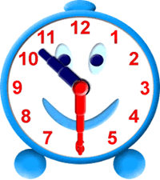
How long did it last?

All of these events started at 10:30.
They finished at different times.
Can you work out how long they lasted for?

Event | Finish Time | Length of Event
Pantomime | 1:00 | hours | minutes
Tour of Wembley | 11:15 | hours | minutes
Big Bike Race | 2:00 | hours | minutes
Round of Golf | 12:20 | hours | minutes
Baking Competition | 3:40 | hours | minutes
Cinema Trip | 1:10 | hours | minutes
Fishing Day | 6:00 | hours | minutes
Birthday Party | 1:50 | hours | minutes
Train Ride | 11:00 | hours | minutes
Trip to the Zoo | 2:20 | hours | minutes
Marathon | 3:10 | hours | minutes
Playing Monopoly | 12:30 | hours | minutes
Rowing Race | 11:05 | hours | minutes
Tour of Annesley | 11:35 | hours | minutes
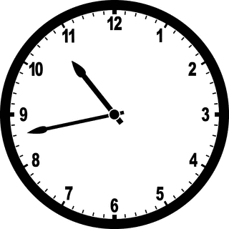
How long did it last?

All of these events started at 10:43.
They finished at different times.
Can you work out how long they lasted for?
Event | Finish Time | Length of Event
Pantomime | 1:03 | hours | minutes
Tour of Wembley | 11:18 | hours | minutes
Big Bike Race | 4:06 | hours | minutes
Round of Golf | 12:24 | hours | minutes
Baking Competition | 3:45 | hours | minutes
Cinema Trip | 1:17 | hours | minutes
Fishing Day | 6:09 | hours | minutes
Birthday Party | 1:54 | hours | minutes
Train Ride | 11:05 | hours | minutes
Trip to the Zoo | 3:26 | hours | minutes
Marathon | 4:15 | hours | minutes
Playing Monopoly | 12:33 | hours | minutes
Rowing Race | 11:05 | hours | minutes
Tour of Annesley | 11:35 | hours | minutes

