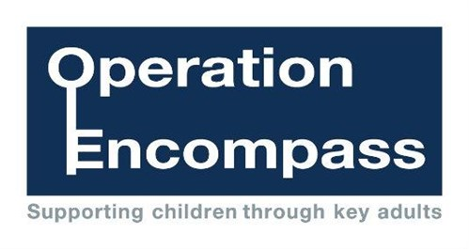
From October 30th 2017 we will be an Operation Encompass School.
This is an initiative developed with Leicestershire Police to ensure that school will be informed before the start of the next school day when a child or young person has been involved or exposed to a domestic abuse incident the previous evening.
This will enable the school to sensitively and appropriately support the child and family to ensure they feel safe and secure after an incident of domestic abuse. If you wish to find out further information about Operation Encompass, please do contact school and ask to speak to Mrs Newman who is our Operation Encompass key adult.

