Year 3 & 4 Spring Homework Project
How do you keep yourself healthy?
Last half term, our Science topic is ‘Animals including Humans – muscles, skeleton and diet’. We would like you to tell us how you keep yourself healthy.
You could:
- Present a PowerPoint about your exercise regime
- Show us photos of you taking part in sports clubs that you do outside of school
- Write instructions for your favourite healthy meal
- Keep a food diary about what you eat in a week
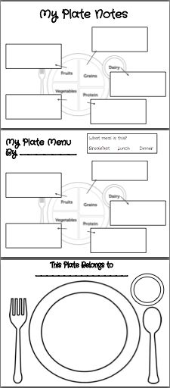
- Create a poster about how a child of your age could keep their body healthy.
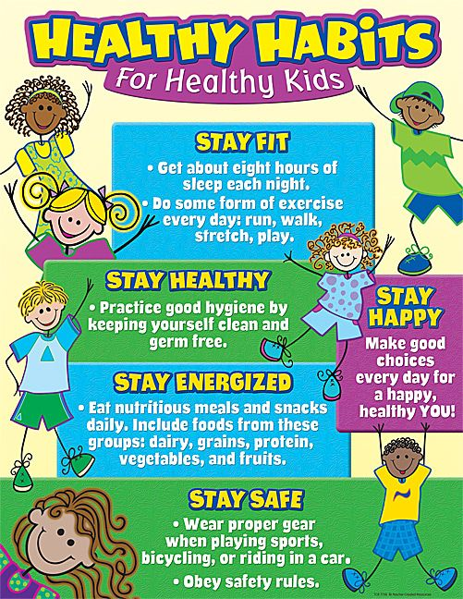
We would like this project to be returned
to school during the first week that we are back please.

