Fractions in a Box
We have a game which has a number of discs in seven different colours. These are kept in a flat square box with a square hole for each disc. There are 10 holes in each row and 10 in each column. So, there would be 100 discs altogether, except that there is a square booklet which is kept in a corner of the box in place of some of the holes.
We haven't drawn a grid to show all the holes because that would give the answer away!
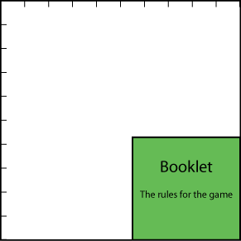
There is a different number of discs of each of the seven colours.
Half (1/2) of the discs are red, 1/4 are black and 1/12 are blue.
One complete row (of 10 holes) of the box is filled with all the blue and green discs.
One of the shortened rows (that is where the booklet is) is exactly filled with all the orange discs.
Two of the shortened rows are filled with some of the red discs and the rest of the red discs exactly fill a number of complete rows (of 10) in the box.
There is just one white disc and all the rest are yellow.
How many discs are there altogether?
What fraction of them are orange?
What fraction are green? Yellow? White?

