Equivalent Fractions
Remember, this simply means fractions which represent the same amount of the whole.
You can use the fractions wall below to help you. I.e. if you look carefully you can see that 1/ 2 is the same amount of the whole as 2/4 and 3/6 and 4/8…
Use this to help you with sheet 1 questions.
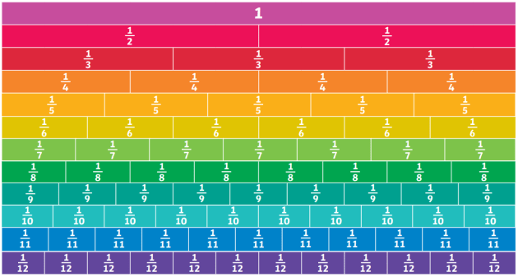

For sheet 2 you must remember that when finding equivalent fractions, whatever you do to the numerator you must do to the denominator (multiplication or division only). Please see the example below to help:
