Activity 4

1. Read about a tourist attraction
- Read Warner Bros. Studio Tour Part 1. Which part of the tour do you think the writer enjoyed the most? Why?
- Challenge yourself to read Warner Bros. Studio Tour Part 2. What does the writer say happens when you’re in Diagon Alley?
- Who do you think these reports are written for?

2. Make notes about the two reports
- Use Information Notes or paper to make notes about some of the facts that are included in the two pieces of writing.
- Use your notes to tell someone else about the Studio Tour.

3. Find out more about the Studio Tour.
- Watch the advert for the tour: https://www.youtube.com/watch?v=jQ_FW0rQS0k
- Now explore the website to find out more information about the tour:
https://www.wbstudiotour.co.uk/explore-the-tour/
- Write about your ideas using ‘What do you think about Harry Potter Studio Tour?’ or a piece of paper.

Try these Fun-Time Extra
- Imagine a theme-park based on your favourite book or film (other than Harry Potter!). What would be included. Can you draw and write to describe it?

Warner Bros. Studio Tour – Part 1
Warner Bros. Studio Tour London – The Making of Harry Potter is unlike any other attraction you have ever visited. You are walking onto the actual set where three young actors became Harry, Ron and Hermione, where Harry was placed into Gryffindor by the Sorting Hat and Ron received his howler from his mum. Surrounded by costumes with tables heaving with prop food and with candles magically dangling in the air, there is so much to see.
Housed at Warner Bros. Studios near London, a vast collection of props, models and sets fill this interactive experience. It’s a treasure trove of all things to do with Harry Potter, and it shows the incredible work done to bring the books of J.K. Rowling to the screen.
The Studio Tour is a three-hour adventure into the heart of the Harry Potter films, from his room under the stairs, to the cosy Gryffindor common room and the Potions classroom. I was blown away by the attention to detail here, including the colourful bottles of spell-inducing ingredients that filled the shelves and blackened cauldrons magically stirring themselves.
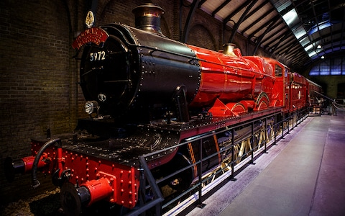

All aboard: follow in the footsteps of the Harry Potter films' stars

Warner Bros. Studio Tour - Part 2
A large proportion of the Studio Tour is dedicated to the animatronics used in the film; these include the snapping Monster Book of Monsters and enormous spiders hanging from the ceiling. I adored the full sized Buckbeak the Hippogriff, and spotting carrots being magically sliced by an apparently floating knife on the set of The Burrow, home to the Weasleys.
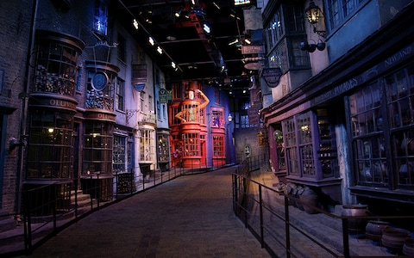
Stock up at Diagon Alley

The tour saves a couple of special “wow” moments to end on a high.
The first is walking onto the set of Diagon Alley, where simply gazing into the windows of the wand-maker Ollivanders, and spotting the boxes of tricks and traps in Weasleys’ Wizard Wheezes, is enough to get a Muggle’s heart racing.
The grand finale is the scale model of Hogwarts Castle, used for external shots, which is immense. Starting high above it, you follow a curling path bringing you down to eye level with the school, where you cannot help but marvel at the detail and care taken in bringing this enchanting world to life.

Information Notes
Who?
What?
Where?
When?

What do you think about the Harry Potter Studio Tour?
Give some reasons why you would like to go on a Hogwarts studio tour. | List the things you would most like to see | What else would you like to find out?

