Neighbourly Addition
As I walked down the street this morning, I noticed that all of my neighbours' house numbers were odd!
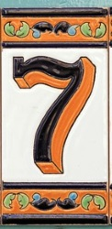 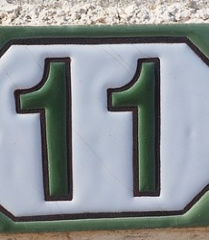
I added three house numbers together as I walked past: 7 + 9 + 11 = 27
Further down the road, I passed some bigger numbers. I added another set of three neighbouring house numbers: 15+17+19 = 51
Can you find some other totals I could make, by adding together the house numbers of three (odd) next-door-neighbours?
Once you've found a few totals, here are some questions you might like to explore:
Is there anything special about all the totals?
Is there a quick way to work out the total?
Can you predict what would happen if I walked down the other side of the street instead (where all the houses have even numbers)?
Are there any patterns if I add together four house numbers instead of just three?
Or five house numbers?
Or...
Can you explain and justify the patterns you have noticed?

