It is our policy that all children should wear school uniform when attending school. We believe that school uniform is important for several reasons:
• It promotes a sense of pride in the school
• It engenders a sense of community and belonging towards the school
• It is practical and smart
• It makes children feel equal to their peers in terms of appearance
• It is regarded as suitable wear for school and good value for money by most parents
• It is designed with health and safety in mind

This policy was written in consultation with parents, children, staff and governors.

The Ashby Hill Top School Uniform is available to purchase from Ashby Schoolwear in Ashby or online at https://myclothing.com/ashby-hill-top-primary-school/5751.school

The uniform is:
- Green Ashby Hill Top Primary School sweatshirt/cardigan with logo (or plain green sweatshirt/cardigan without logo)
- White polo shirt with/without logo or green polo shirt with/without logo or a white shirt
- Grey trousers/shorts/skirt/pinafore (no black)
- White/grey/black socks or grey/black/green tights
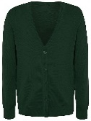 | 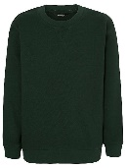 | 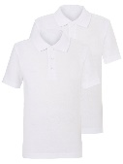 | 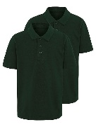 | 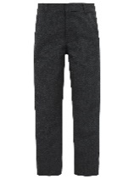 | 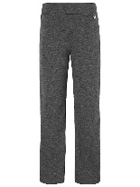 | 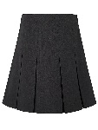 | 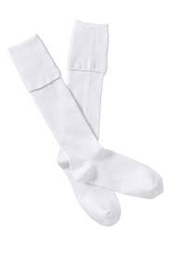  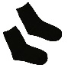  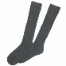 | 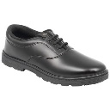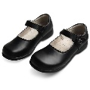
- A green checked summer dress may be worn in the summer months
Please name all items, including shoes and coats, to ensure lost items can be identified and quickly returned to their owner!
Footwear
Children should wear black shoes for school or boots in the winter. They should not wear heeled shoes, ‘Ugg’ style boots or trainers for school. (If in doubt please speak to the Headteacher before purchasing footwear.)
PE Uniform:  PE kits are essential and should be named and stored in a named PE Bag. A school PE bag can be purchased from our uniform suppliers. | 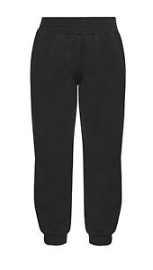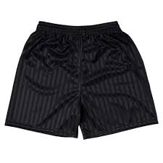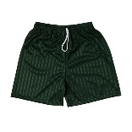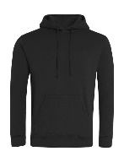
Indoor  - White school logo PE shirt (or plain white T-Shirt)  - Green or black shorts  - Plimsolls | Outdoor  - White school logo PE shirt (or plain white T-Shirt)  - Black shorts/track suit/jogging bottoms/leggings with black sweatshirt/hoodie  - Trainers

Jewellery
Stud earrings and a watch are the only forms of jewellery permitted. If your child does wear earrings, these need to be removed or covered with ‘micropore’ tape for PE. It is the responsibility of the parents to provide their child with ‘micropore’ tape.

Book Bags
A named book bag can be purchased from Ashby Schoolwear in Ashby or online at https://myclothing.com/ashby-hill-top-primary-school/5751.school. A book bag is very useful for carrying books, homework and other home-school communication items.

Other Information
Hair accessories should be kept to a minimum, extravagant fashion items are not permitted.

Please ensure that hair is an appropriate colour/style for school.

Make up and nail varnish are not permitted.

Health and Safety
For health and safety reasons, long hair should always be tied back for PE and science.

The school reserves the right to require pupils to change any items of clothing, headgear or footwear, which are considered unsuitable for school wear.

